In-Class Exercise: Basic Charts

This Excel file contains fictitious pharmaceutical sales information. Create a Tableau worksheet to answer each of the following questions:

**FILE to use: SuperDrugsPrescriptions.xlsx**

1. Exactly recreate the following visualization of the average prescription price over time:

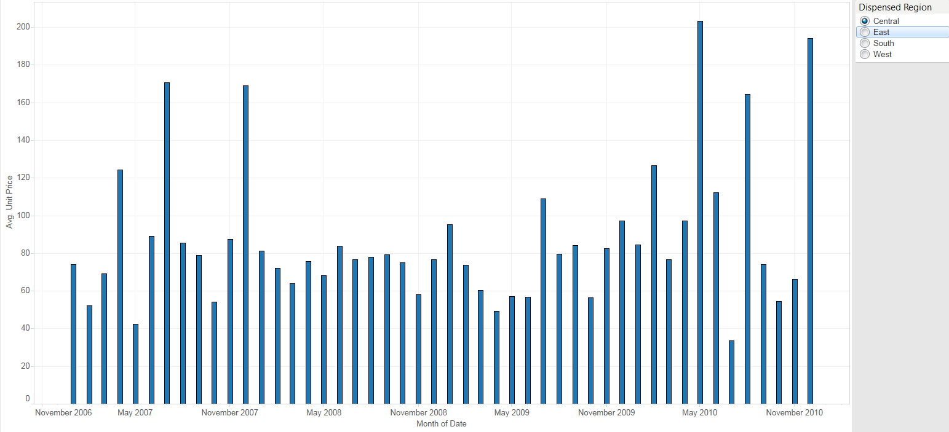

1. Exactly recreate the following visualization of prescription quantity vs. profit. The color of each mark denotes the region, and the shape denotes the drug supplier:

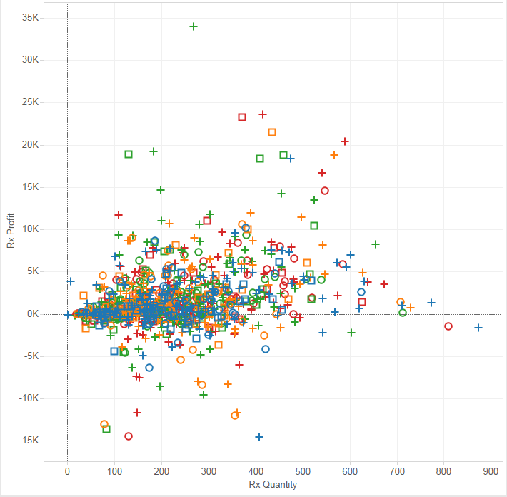

Use the viz you just created to answer the following:

* What pharmacy and drug supplier represented the highest profit mark on this viz, across all regions?
* What pharmacy and drug supplier represented the highest profit mark on this viz in the East region?